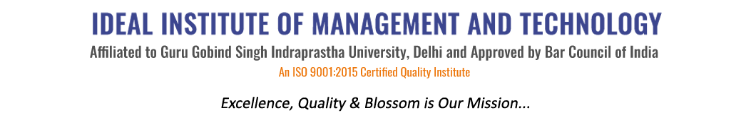
16 X, Karkardooma Institutional Area, (Near Telephone Exchange)
Delhi-110092
+91 (11) 22372639, 22375961,
http://idealinstitute.edu.in
INDUSTRIAL VISIT MOTHER DAIRY - 17TH NOVEMBER' 2015
BBA 2ND SHIFT
S.no. | Name | Class |  | Attendance | Attendance
1 | Prachi | CAM-4
2 | Farheen | CAM-4
3 | Jai | CAM-4
4 | Harshit | CAM-4
5 | Gunjan | CAM-4
6 | Pragya | CAM-4
7 | Utkarsh | CAM-4
8 | Ashutosh | CAM-4
9 | Saba | CAM-4
10 | Vikram | CAM-2
11 | Anubhav | CAM-2
12 | Abhishek | CAM-2
13 | Deepanshu | CAM-2
14 | Ruchika | CAM-2
15 | Vishv | CAM-2
16 | Piyush | CAM-4
17 | Jhanvi | CAM-4
18 | Riya | CAM-4
19 | Divyansh | CAM-2
20 | Gaurav | CAM-2
21 | Saumya | CAM-2
22 | Aman | GEN-4
23 | Sukhleen | GEN-4
24 | Pranjal | GEN-4
25 | Vaibhav | GEN-2
26 | Apurva | GEN-2
27 | Samiksha | GEN-2
28 | Shalu | GEN-2
29 | Parul | GEN-2
30 | Lipi | GEN-2
31 | Chetan | GEN-2
32 | Cheshtha | GEN-2
33 | Arpit | GEN-2
34 | Garima | GEN-2
35 | Ayushi | GEN-2
36 | Apoorv | GEN-2
37 | Archit | GEN-2
38 | Abhishek | GEN-2
39 | Saksham | GEN-2
40 | Anant | CAM-2

